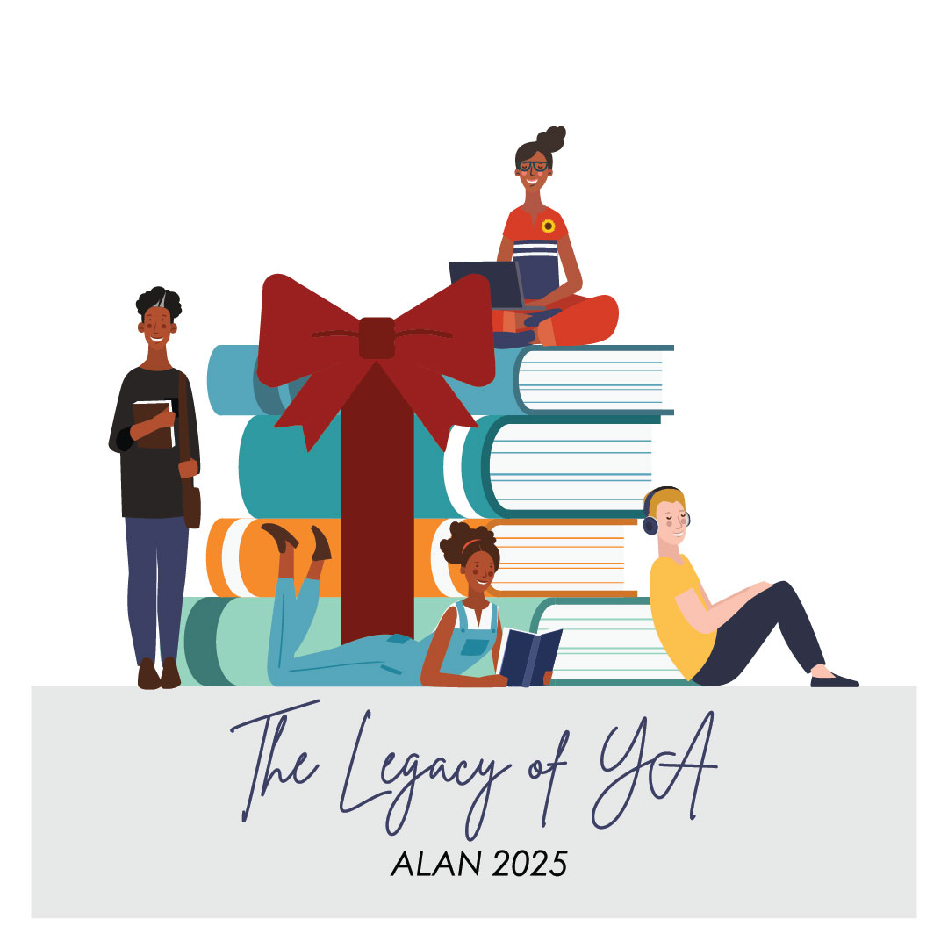
“The Legacy of YA”
ALAN Workshop
Denver, Colorado
November 20-23, 2025

When ALAN turned 50, I started to think about its legacy. Maya Angelou once said, "Your legacy is every life you touch!” ALAN has touched a lot of lives, especially my own. ALAN’s legacy has been a gift, a message, bequeathed to each and every one of us, printed in our minds and hearts.

At next year’s ALAN workshop, I want us to reflect on over 50 years of ALAN while also considering our present and our “liberatory futures.” It is key that we cultivate a legacy for future generations of students and educators. So, where will we take YA in the next fifty years? Will we pass on a legacy of resisting efforts to hamper an adolescent’s right to read? Will we perpetuate a legacy of inclusivity, antiracism, and antibias?

With building on ALAN’s legacy centered, the 2025 ALAN workshop will feature authors, illustrators, narrators, editors, and publishers
who create with diverse readers in mind;
who thoughtfully consider complex topics and prioritize accurate, honest, depictions of history and the current moment;
and who seek to catalyze readers’ imagination, identity formation, and agency.

We are seeking poster session proposals focused on how educators, librarians, and youth advocates can share bold, liberatory visions of reading, teaching, and critically responding to YA literature.

ALAN 2025 Poster Presentation Form: Due March 20, 2025

We are seeking poster presentations on any topic related to adolescent literature that will benefit ALAN attendees connected to the ALAN 2025 theme, “The Legacy of YA.” Poster session presenters populate boards with pictures, data, graphs, diagrams, and narrative text and informally discuss their poster with conference attendees during the presentation session. It is recommended to also include a take-home aspect of your poster attendees can access later (ex., QR code, handout, bookmark, etc.)

We value books and presentations that feature authentic, diverse perspectives and insist that all poster sessions be interactive.

Note: Since YA authors will be featured throughout the majority of the program, we are reserving the poster sessions for teachers, librarians, university educators, publishers, and others who are not YA authors.

Important Details:

- All applicants must be members of ALAN (Assembly on Literature for Adolescents of the National Council of Teachers of English). You can join or renew your membership at http://www.alan-ya.org/join/.
- Electronic submissions are due no later than midnight (EST) on March 20, 2025, and should be sent to: KaaVonia Hinton (khintonj@odu.edu) with the subject line “ALAN Poster Session Proposal.”
- Please email submission as a Google document or a word document. Submissions will be blinded before committee review.


Please note that poster sessions may be about research, class activities, book studies, book reviews, etc. We are looking for all levels and professions within ALAN to be represented. Anything that would benefit ALAN attendees as connected to the ALAN 2025 theme is welcome. Additionally, the format of the poster is up to the author though it should be paper-based, not digital (see above for examples).

Poster Session Proposal Form
Due March 20, 2025

Proposed Poster Title:

Audience:

Corresponding Presenter’s Name & Email Address:
*This person will be emailed and expected to share information with the other presenters.

Names of all Presenters and Institutional Affiliations and Positions:
*Please note any potential first-time ALAN attendees

Email addresses:
*Please be sure to include email addresses for all presenters.

Description and purpose of poster session (500 words or fewer):

Specific texts you are highlighting in your session (if any):

Summary to be included in the program (50 words or fewer):

Description of how the poster session will be interactive (100 words or fewer):

Connection with this year’s workshop theme (100 words or fewer):

Positionality statement (Position yourself to the content you are presenting. Why did you choose to present on this subject? How are you positioned in terms of the content you are presenting—your professional expertise and your identities [e.g., ability, gender, race, ethnicity, etc.]? What potential biases, assumptions, and values might inform your approach to this topic?) (100 words or fewer):

In 2020, ALAN created the Anti-Racist Breakout Session award, which is dedicated to implementing anti-racist work in schools, libraries, and/or universities and awarded annually. The intent of the session is to continue the conversation and provide actionable items and recommendations for attendees to implement in their different contexts. The speaker(s) will be awarded a $500 honorarium as a way to recognize their labor, care, and commitment. Please indicate here if you would like your presentation to be considered for this award.

